**www.rsis.edu.sg No. 001 – 20 August 2021**

*The authors' views are their own and do not represent the official position of the Institute of Defence and Strategic Studies of the S. Rajaratnam School of International Studies, NTU. These commentaries may be reproduced with prior permission from RSIS and due recognition to the authors and RSIS. Please email to Editor IDSS Paper at* [*RSISPublications@ntu.edu.sg*](mailto:RSISPublications@ntu.edu.sg)*.*

No. 001/2021 dated 20 August 2021  
**America, ASEAN and the Question of ASEAN’s Centrality** *By See Seng Tan*

When a player fumbles the ball in the game of American football, it typically leads to a scramble by the two rival teams to recover the ball and make plays. Not dissimilarly, after a technical glitch prevented US Secretary of State Antony Blinken from connecting with the foreign ministers from the 10-nation Association of Southeast Asian Nations (ASEAN) back in May, the door was wide open for China to steal a march on the United States. Two weeks after Blinken’s fumble, Chinese State Councillor and Foreign Minister Wang Yi welcomed the ASEAN foreign ministers to an in-person gathering in Chongqing in southwestern China, where assurances over economic exchanges and COVID-19 pandemic-related assistance flowed freely.

Fair or otherwise, Blinken’s unforced error (to borrow another sporting metaphor) has come to be seen as emblematic of the Biden administration’s perceived neglect of Southeast Asia and of ASEAN a mere few months into its tenure. Reactions from the pundits were focused primarily on the Biden team’s missteps — a sense sharpened not just by the apparent success of the China-ASEAN meeting, but also by the fact that Blinken had sat in on President Joe Biden’s virtual meeting with his Quad counterparts from Australia, India and Japan earlier in March. By personally engaging with the Quad but not with ASEAN, President Biden inadvertently fostered the impression that his Asia policy has more in common with that of his predecessor, Donald Trump, than not. Reportedly, Biden has yet to have an official phone conversation with any of the 10 ASEAN leaders (though some of his top administration officials have). Rhetoric aside, the optics did not seem to match Biden’s promise to re-engage with ASEAN in the wake of Trump’s desertion of America’s longstanding role of international leadership, disregard for US allies and partners, and disinterest in the ASEAN region.

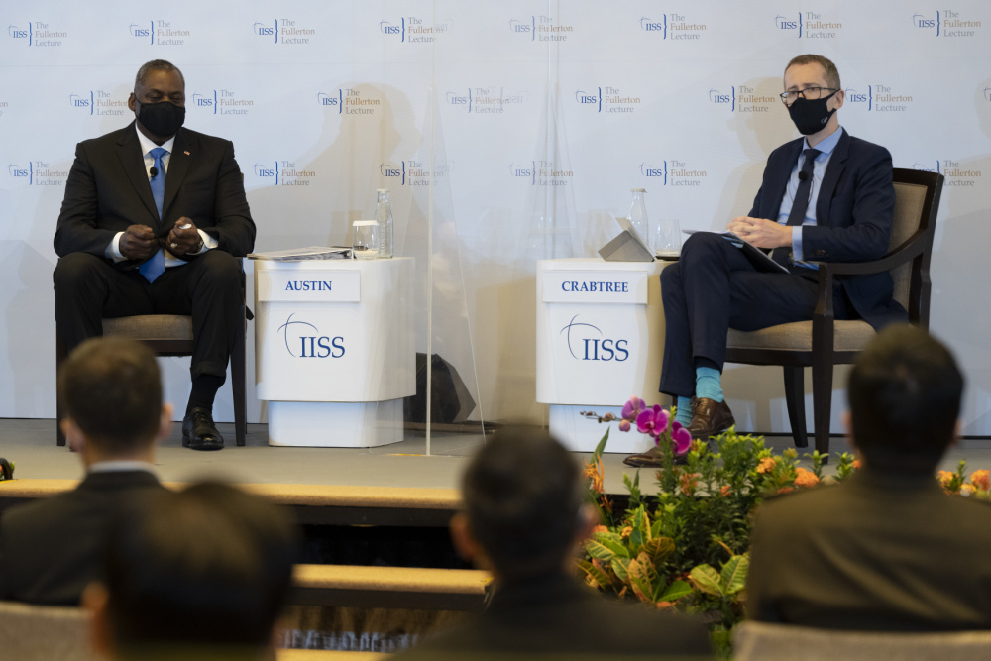  
Lloyd Austin and IISS-Asia Executive Director James Crabtree at the 40th Fullerton Lecture.  
*The appearance of U.S. Department of Defense (DoD) visual information does not imply or constitute DoD endorsement.*

**Better Late Than Never?**

But since the May fumble, the Biden administration has been scrambling in recovery mode. Blinken finally if belatedly held a video conference on 14 July with the ASEAN ministers — including a representative from Myanmar appointed by junta leader General Min Aung Hlaing — and discussed an array of hot-button issues ranging from the crisis in Myanmar and the COVID-19 pandemic in Southeast Asia to the maritime disputes in the South China Sea. He urged his ASEAN counterparts to put an end to the violence in Myanmar, restore that nation to its democratic transition and work for the release of all political prisoners — points wholly consistent with the “five-point consensus” reached by the ASEAN leaders and Min Aung Hlaing at their 24 April meeting in Jakarta. In his remarks on the South China Sea, Blinken not only reaffirmed Washington’s rejection of Beijing’s “unlawful” maritime claims in those waters and its support for Southeast Asian claimants in the face of Chinese “coercion”, but — hinting at China’s controversial dominance in the Mekong — also drew attention to his administration’s promotion of a “free and open Mekong region” under the Mekong-US partnership.

Two weeks later, US Secretary of Defense Lloyd Austin did better than his counterpart at State, with a three-country tour, *in person*, of Singapore, Vietnam and the Philippines — the first cabinet-level official in the Biden administration to visit Southeast Asia. In an IISS Fullerton Lecture during his Singapore stopover, Austin emphasised four big points. First, he stressed that the Biden administration was committed to pursuing a “constructive, stable relationship” with China and ensuring the maintenance of the “international rules-based order”.  Second, he underscored the importance of allies and partners in the Biden administration’s coalition-building effort. Third, he focused on Washington’s efforts to supply the region and the world with free anti-COVID vaccines, which is a key aspect of soft-power diplomacy that the Trump administration’s foreign policy lacked. Fourth — and crucial to Singapore, which has long insisted on these as essential elements for great-power engagement with Southeast Asia — Austin extolled the centrality of ASEAN and reassured the region that his government does not expect the ASEAN states to choose between the United States and China.

Austin’s Singapore visit unveiled a series of high-end bilateral defence cooperation opportunities. These include the signing of an MOU establishing a Republic of Singapore Air Force fighter training detachment in Guam, as well as news concerning the hosting of Singapore’s future F-35B fighter aircraft detachment at Ebbing Air National Guard Base in Arkansas (reportedly the new home as well for Singapore’s F-16 fighter training detachment following its relocation from Luke Air Force Base in Arizona).

In Hanoi, Austin sought to advance his country’s security ties with Vietnam. That said, the readiness by both sides to up their security relations — despite Vietnam having received US military hardware, including coastguard cutters to bolster its claims in the South China Sea against those of the Chinese — is likely to be constrained by Washington’s concerns over Vietnam’s human rights record and Hanoi’s lingering discontent over the US disengagement from the Trans-Pacific Partnership.

Austin’s visit to Manila was met by Philippine President Rodrigo Duterte’s decision to keep his country’s Visiting Forces Agreement (VFA) with the United States, which furnishes rules for the rotation of thousands of US troops in and out of the Philippines for war drills and exercises. Back in early 2020, Duterte had vowed to end the VFA, a move that hinted at the time of a major break in the US-Philippines security relationship as Duterte sought — not without opposition at home however — to align his country closer with China. While it cannot be said with any confidence that Duterte’s about-turn in favour of retaining the VFA represents a decisive shift away from Beijing, at the very least it arguably reflects Manila’s commitment to hedging between the major powers.

**Caught, but Not Trapped, in the Middle**

Not surprisingly, the Biden team’s efforts drew rebuttals from Chinese officials and pundits. Blinken’s video call with the ASEAN ministers — reportedly described to the media by one participant as “very civil” — was deplored by a Chinese foreign ministry spokesperson as an effort by Washington to sow discord among the ASEAN countries and stoke disputes. In anticipation of Austin’s visit to Southeast Asia, Hu Bo, a Chinese South China Sea expert, argued in a *Global Times* op-ed that “[with] a relative shortage of capabilities and tools to influence Southeast Asia, security and defence cooperation have become ‘life-saving straws’ for the US to exploit Southeast Asia”. Rather than anything else of value that America still has to offer the region, it is US military support that alone constitutes “the real backdrop to Austin’s visit to Southeast Asia”, Hu contended. Fairly or otherwise, the current optics of US diplomacy seem to support this claim, not least when America’s top diplomat relied on video conferencing to communicate with his ASEAN counterparts, while his defence counterpart took pains to visit Southeast Asian countries that are both allies or partners of the United States and — in the case of Vietnam and the Philippines — South China Sea claimant states.

But do these efforts prove the veracity of claims about the apparent poverty of the Biden administration’s policy on and approach towards Southeast Asia? And if so, are the ASEAN states ready to turn tail on the United States and embrace China, whether wholeheartedly or reluctantly? Unlikely, it seems. Comments by Blinken and Austin on ASEAN’s difficulties with Myanmar do not seem to have aroused negative reactions from the Southeast Asians, some of whom have publicly voiced their frustrations with the Burmese junta’s recalcitrance. And if any of them bemoan the likelihood of the Biden administration being vocal on their own human rights records, it is not impossible that some ASEAN states may even deem such criticism as not intolerable if it is accompanied by a firm but measured US policy on China sans the risky brinkmanship employed by the Trump administration. Indeed, it is interesting that despite Trump’s petulance, Southeast Asians have for the most part been a forgiving lot. According to a 2021 survey of Southeast Asian elites conducted by the ISEAS-Yusof Ishak Institute in Singapore, the majority in the region continue to welcome America’s strategic influence — notwithstanding Washington’s abysmal record on the pandemic, race relations and the state of democracy at home — and anticipate a strong rebound in engagement of the region by the Biden administration. Indeed, when asked how they would decide if they were ever forced to choose sides in the US-China rivalry, most respondents picked the United States.

**Ensuring ASEAN Centrality**

But there is a deeper concern for ASEAN: warm sentiments toward America aside, the perception of unrequited attention, let alone affection, from the United States, especially in the light of the relentless growth of Chinese influence, renders difficult ASEAN’s ability to effectively maintain its centrality in East Asian regionalism. We may recall that the ASEAN Charter emphasises the need to “maintain the centrality and proactive role of ASEAN as the primary driving force in its relations and cooperation with its external partners in a regional architecture that is open, transparent and inclusive” (see Article 1). ASEAN Centrality is also viewed as a benchmark for the shaping of the grouping’s relations with other powers and international bodies; it is, as one observer has put it, “the glue that binds key actors together, either through direct membership or via regional structures.”

What is missing from these observations, however, is the unspoken fact: ASEAN Centrality exists not only when the external powers and its dialogue partners acknowledge it, but because these players engage deeply with ASEAN and treat it as a regional actor of consequence. The Biden administration has declared its commitment to ASEAN Centrality and ASEAN’s essential role in the Indo-Pacific architecture — as reflected in more than a dozen high-level calls and in-person meetings and most recently by Secretary Austin’s visit to the region. In her role as architect and executor of the Obama administration’s pivot to Asia, Hillary Clinton made 62 visits to Asian countries — including three trips to Cambodia, two to the Philippines and four to Indonesia — during her stint as secretary of state and became the highest-ranking US official ever to visit the ASEAN Secretariat in Jakarta. By showing up, Clinton underscored ASEAN’s centrality to her government’s Asia strategy. It is telling that ASEAN leaders view and explain developments such as the maritime exercises China and the United States consecutively pursued with all 10 of them — beginning with the Chinese in 2018 in Zhanjiang in China’s southern Guangdong province, and following with the Americans in 2019 at the Sattahip Naval Base in Thailand — as proof that ASEAN Centrality is alive and well because the major powers readily engage with ASEAN and value its relevance to the region.

But for all their insistence that the United States and other big powers ought to engage with the region on the latter’s terms, ASEAN leaders are painfully aware that there is no better measure of ASEAN Centrality than when they themselves “show up” where it matters — through acts of institutional solidarity and substance that contribute meaningfully to the region’s peace, security and stability. As Prime Minister Lee Hsien Loong of Singapore once conceded, ASEAN’s centrality is not a given. Likewise, while noting that ASEAN had done well at providing a “centrality of goodwill”, the late Surin Pitsuwan, the secretary-general of ASEAN from 2008 to 2012, argued that what the regional organisation needed to furnish, however, was a “centrality of substance” as it faced more demanding tests to its solidarity arising from ongoing shifts in the power dynamics and trade patterns of East Asia. In recent years, ASEAN has struggled with a host of challenges — the Rohingya refugee crisis, the South China Sea disputes, and the ongoing political crisis in Myanmar — that have done more to undermine its own centrality than anything else could ever do.

In the “new normal” of US-China strategic competition, ASEAN Centrality is needed more than ever if the region is to stay open and inclusive, secure and stable. That can only happen if the region’s stakeholders — America and ASEAN, among others — do their part.

*See Seng Tan is President/CEO of International Students Inc. (ISI) in the United States. Concurrently, he is Research Adviser at RSIS and Senior Associate at the Centre for Liberal Arts and Social Sciences (CLASS), both at Nanyang Technological University.*

**S. Rajaratnam School of International Studies, NTU Singapore**Block S4, Level B3, 50 Nanyang Avenue, Singapore 639798

T: +65 6790 6982 | E: [rsispublications@ntu.edu.sg](mailto:rsispublications@ntu.edu.sg) | W: [www.rsis.edu.sg](http://www.rsis.edu.sg)